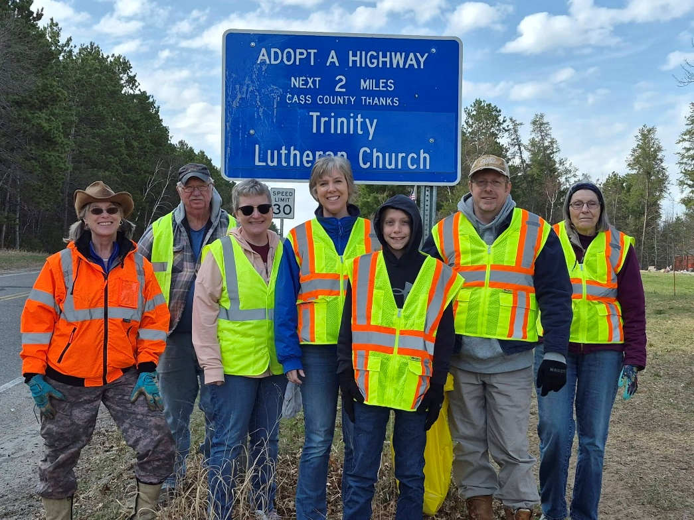
Many thanks to our volunteers who cleaned up 2 miles of Cty Rd 46 in Cass Lake on Saturday, May 2. We spent about 2-1/2 hours on the cleanup, and a good time was had by all. This is part of our God's Work, Our Hands ministry at Trinity Lutheran.
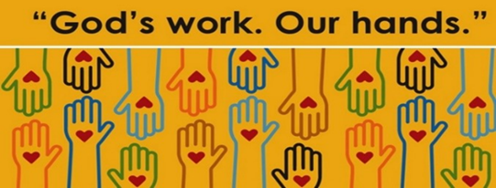
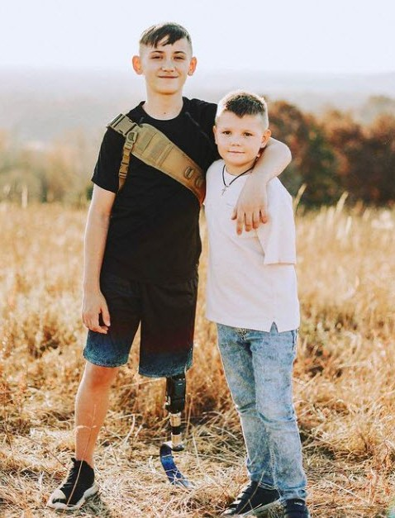
FAITH AND VOLUNTEERISM
Bemidji resident Peter Nordquist reflects on eight mission experiences in Ukraine since the war began four years ago.
Peter will share slides, video clips and stories of strength and faith during trauma, and the resilience of the Ukrainian citizens he encountered.
Thursday, May 14th, 7:00 pm at Bethel Lutheran Church in Bemidji, finishing promptly at 8:00 pm. Coffee and dessert will be served in the fellowship hall.

